Emergency Response Plan:

Bonnyville Angels

Peter Kushnir Ball Park – Bonnyville, AB
Emergency Phone Number: 9-1-1 for all emergencies
Bonnyville Centennial Centre: Facility Across from Ball Diamonds (West)
4313 50 Ave, Bonnyville, AB T9N 0B4
(780) 812-3400
First Aid Station / AED Device available

Address of Home Facility; Peter Kushnir Ball Park:
4109 50 Ave
Bonnyville, AB T9N0B4
54.268564,-110.72213454°16'06.7"N 019.7"W
Contact #s:
Hospital (Bonnyville) (780) 826-3311
Fire (Bonnyville) (780) 826-3211
Police (Bonnyville) (780) 826-3358
Alberta Forestry FIRE Lac La Biche Wildfire Management Area 780-632-5245 or DIAL 310-3473
Poison Control 1-800-332-1414
DIRECTIONS TO HOSPITAL Bonnyville Healthcare Centre: 5001 - Lakeshore Drive.
-Travel West on 50Ave – Approx. 5 blocks to 50th Street (2nd Traffic Light)
-Turn South (left), travel 2 blocks to the front entrance of the hospital.
Directions to Bonnyville Healthcare Centre: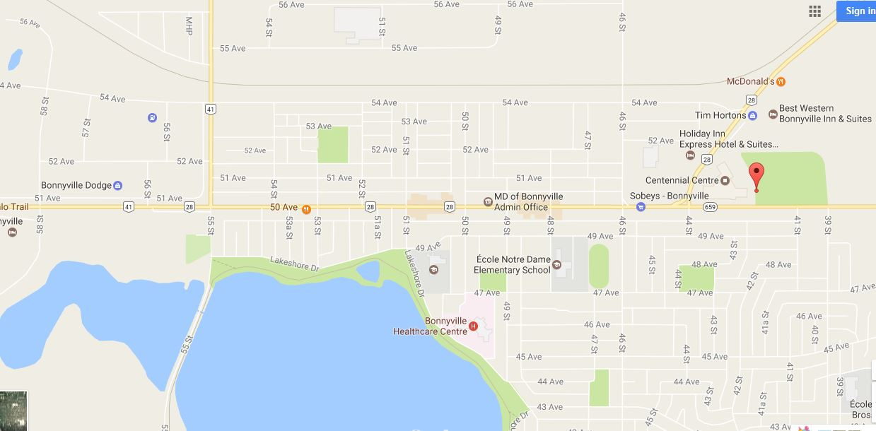

Teams Lead Name: (Head Coach) 780-xxx-xxxx
Charge Person (1st Option): Name: (Asst.Coach) 780-xxx-xxxx
Charge Person (2nd Option): Name: (Asst. Coach) 780-xxx-xxxx
Charge Person (3rd Option): Name: (Asst. Coach) 780-xxx-xxxx

Call Person (1st Option): Name: (Asst. Coach) 780- xxx-xxxx
Call Person (2nd Option): Name: (Team Manager) 780- xxx-xxxx
Call Person (3rd Option): Name (Team Manager) 780- xxx-xxxx

****Please ensure “your” /“visiting” team contacts are specific during your game.****
Roles and responsibilities:
Charge person
- Clear the risk of further harm to the injured person by securing the area and
shelter the injured person from the elements
- Designate who is in charge of the other participants
- Protect yourself (wears gloves if he/she is in contact with body fluids such as
blood)
- Assess ABCs (checks that airway is clear, breathing is present, a pulse is
present, and there is no major bleeding)
- Wait by the injured person until EMS arrives and the injured person is
transported
- Fill in an accident report form
Call person
- Call for emergency help
- Provide all necessary information to dispatch (e.g. facility location, nature of
injury, what, if any, first aid has been done)
- Clear any traffic from the entrance/access road before ambulance arrives
- Wait by the driveway entrance to the facility to direct the ambulance when it
arrives
- Call the emergency contact person listed on the injured person’s medical profile
Bonnyville Alternate Diamonds - 