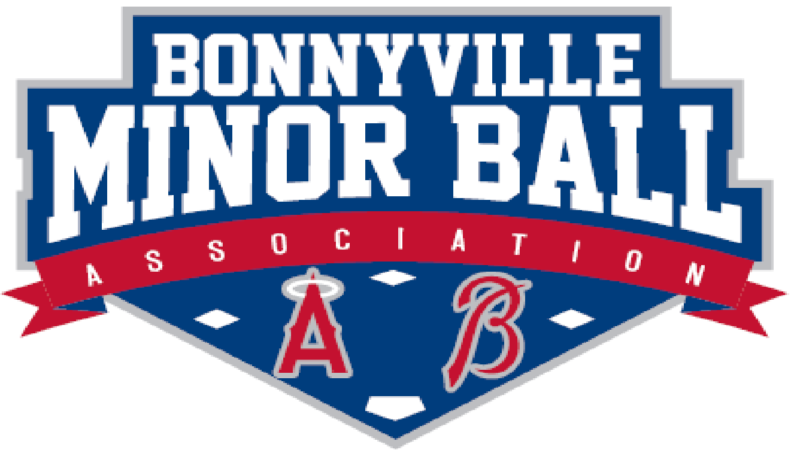

To Whom It May Concern:
____________________ has signed up to be a volunteer with the Bonnyville Minor Ball Association during the 2023 season. We request a criminal record and vulnerable sector check on this individual in order for them to be able to help with the children registered in baseball, softball, or T-ball this year.

Thank you,
Real Bourbeau
President
Bonnyville Minor Ball

